PCB requirements
PCB files name：snowflake-hw-v1.0.1.zip
1，Material requirements
layer ：4 layers（4 层）
thickness：1.6mm +/-10%
material：FR4 Tg150
surface treatment ：matte white oil, Plug Hole, IMMERSION GOLD ，black silkscreen , VIPPO ，Impedance error 5%
（亚光白油，填孔，沉金，丝印黑色）
Note: 生产跟踪丝印请放置底层的模块底部
2, layers arraying（板层排列）：
snowflake-hw-v1.0.1 R5.GTL TOP 0.035mm +/-20%
pp 0.3344mm +/-15%
snowflake-hw-v1.0.1 R5.G2L 2layer 0.035mm
core 0.865mm +/-15%
snowflake-hw-v1.0.1 R5.G15L 5layer 0.035mm
pp 0.3344mm +/-15%
snowflake-hw-v1.0.1 R5.GBL bottom 0.035mm +/-20%

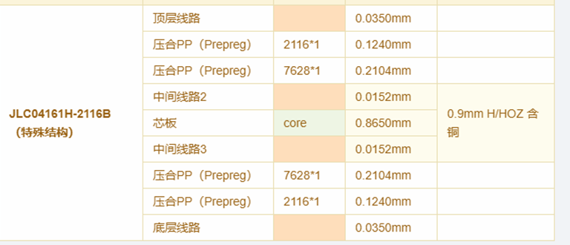

4，90 ohm difference line
the parallel line is 90 ohm difference line, the layer2 difference line reference layer is the layer1 and layer3, (图中平行线为90差分线，第2层差分线参考层为第1层和第3层)
